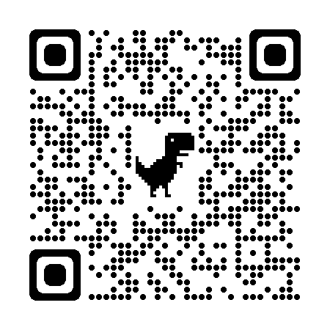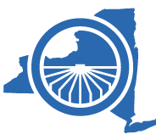

**Resources for Farm Owners:**

Go to https://www.nysmigrant.org/resources/agribusiness-owners or scan the QR code below with your phone’s camera, to access a variety of useful resources, including:

* A free *Spanish for Agribusiness Owners* book to help you learn Spanish words and phrases that will be useful on and around the farm
* OSHA-compliant bilingual farm safety signs
* Bilingual COVID-19 resources

**The New York State Migrant Education Program is here to support the farm owner and farmworker community during the COVID-19 pandemic. For the health and safety of your farm and your workers, some services will be provided remotely at this time. When we do conduct home visits, we will be following strict social distancing protocols for our safety, and for the safety of your workers and your property. Our staff will maintain 6 feet of distance and will be wearing proper Personal Protective Equipment (PPE). Services we may provide include:**

* Information about how to stay healthy and safe during the COVID-19 pandemic.
* Drop-offs of materials and resources as needed, including educational materials, COVID-19 test kits, and/or PPE.
* Virtual and in-person instructional services, including English as a Second Language instruction for workers who qualify for our program, and instructional support for school-aged children.

### Recruiter Contact Info:

___________________________

___________________________

___________________________

Migrant Education Program

100 Saratoga Village Blvd, Suite #41

Ballston Spa, NY 12020

Phone: (518) 417-3609

### NYS Migrant Education

The Migrant Education Program helps the children of farmworkers and young farmworkers under 22 years of age who have moved and engaged in farm work within the past 3 years. A variety of services can be provided to those who qualify, including English as a Second Language instruction, and summer programs. All enrollments and services at this time will be completed by phone. If you think one of your employees may qualify, please give us a call:

# Support for Farmers and Farmworkers