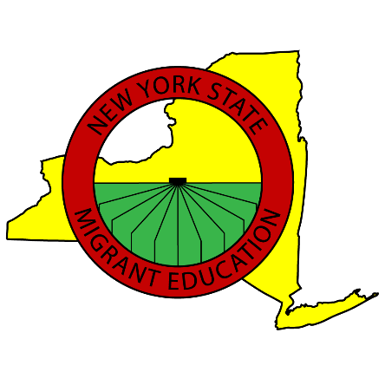

Have you worked on a FARM?

Is anyone in your family under 22 YEARS OLD?

YES? We may be able to help!
MIGRANT EDUCATION
TUTORIAL AND SUPPORT
SERVICES PROGRAM

School enrollment, tutoring, free lunch eligibility, ESL and TASC classes for farmworker youth, and other educational services.

CALL US!
Office: 1-800-451-8058
Toll Free:
1-800-234-8848
